New Year’s Eve in St. John’s:
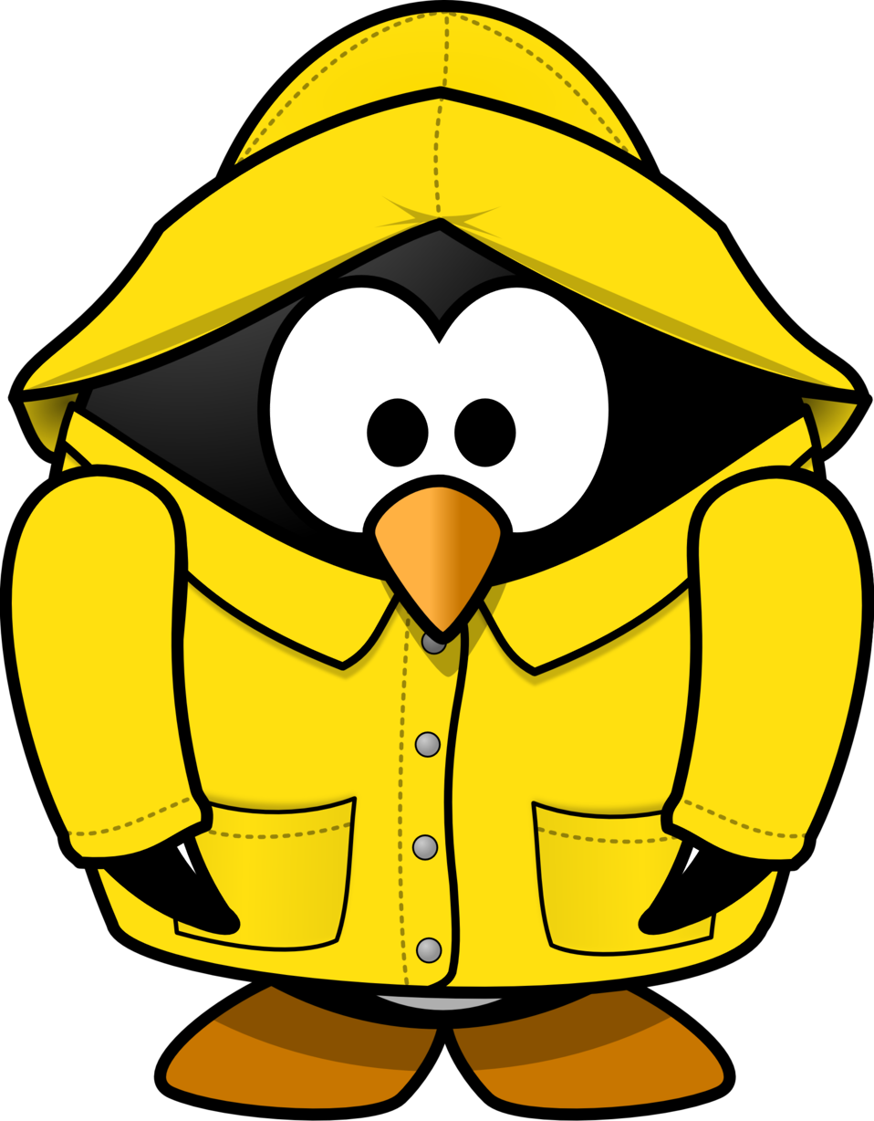
A Newfoundland Dinner and Delights
December 31, 5:00 to 7:30pm (that’s midnight in Nfld!)
Live Music with a Maritime feel

Board Games and silly contests

Mock “Kiss the Cod and Screech-in”

Sparkling Apple Juice Toast at 7:30pm

Sing-along to close the night

Tickets: $25 adults
$15 ages 6 to 17
Children under 5 free
(child-friendly meal available)
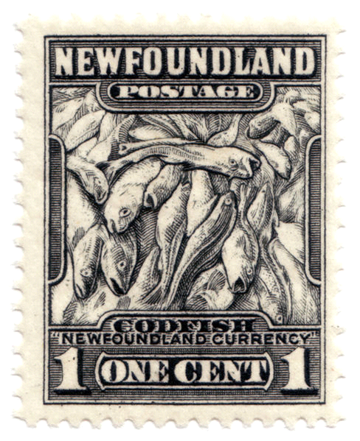

St. John’s United Church, Davis Bay
5085 Davis Bay Road, Sechelt
Doors open at 5:00pm
Only 50 seats available! Get tickets through St. John’s United Church in Davis Bay- call 604-885-9822

